THERAPY WITH MEDICINA AYAHUASCA
In a ceremonial and caring environment

Your guide Don Ino : +52 33133 58095 ( cell / whatsapp )

New: your donations are now accepted:
In addition to your regular contribution and if you have been particularly pleased with the experience you will have the possibility to leave an extra donation . You will thus contribute to our charitable actions in Mexico such as helping young drug addicts and victims of drug traffickers.
A donation box will be located near the entrance door to the ceremony hall.
Your donations in kind are also accepted on the day of the ceremony (healthy food such as fresh or dried fruit, organic drinks and biscuits). They will be shared among all participants when breaking the fast.
Thank you,
Don Ino.
Also remember that the use of Ayahuasca, despite its undeniable therapeutic virtues, is not yet authorized in some countries. Great caution is therefore advised when discussing with third parties.
WARNING: We are seeing a dramatic increase in overdoses around the world due to the presence of the Fentanyl molecule in many narcotic products sold on the black market. It is recommended to carefully check your supply sources. Remember that Fentanyl is 100 times more powerful than opium.
El Refugio del Buho is aware of this situation and guarantees the origin and purity of its sacred plants. Each arrival is systematically tested by us during a ceremony attended by 3 guides and a doctor.

DESCRIPTION OF THERAPY :
Therapy or meditation and introspection with sacred medicine, the Great Spirit, the Master Plant or Grandmother Ayahuasca , is an opportunity for self-knowledge and reconnection with our true inner being, with the inner teacher, and from there, to find physical, emotional and mental healing through forgiveness, understanding the processes of life, joy, unconditional love. The high frequency vibrational states in which the participants are immersed undo the energetic blockages generated in the path of life and which have sickened our relationships, mainly that with ourselves. Wanting to participate in this ceremony should come from a call from our conscience and a desire to do so in a liberating but respectful atmosphere.
Thank you for allowing me to be part of this journey in reaching to your higher self. Remember it has all the answers and the Medicina is a vehicle to remember and reconnect with your wisdom. The medicine is you! I am the guardian of this ancestral wisdom and I will respectfully be your guide and accompany you responsibly in your approach. Respecting the millennial lineage, I thank my teacher and his teachers and the sacred energy of Grandmother Ayahuasca .

DESCRIPTION OF AYAHUASCA:
Banisteriopsis caapi (inhibitor in the stomach of MAO, carrier of Dimethyltryptamine or DMT) a vine from Amazonia which mixed with another plant called Chacruna (DMT) gives the Drink (Medicine, concoction, potion, infusion), called Ayahuasca , known as the sacred and teaching plant. In Quechua, ayahuasca means "rope of the spirits" due to its

etymology aya spirit, death and waska "rope, rope", since in the indigenous people’s worldview, ayahuasca is the rope that allows the spirit to leave the body without it dying.
Used for more than 5000 years by shamans, healers or Ayahuasquero masters of the Amazon as a means of obtaining the expansion of consciousness , it is now used in all Latin America in rehabilitation centers to treat people addicted to hard or forbidden drugs and legal drugs such as antidepressants.
Ayahuasca is also the sacrament of several Brazilian churches, such as Santo Daime or the União do Vegetal, which have developed throughout the Americas and in Europe, with adapted protocols and rites, confirmed by experience and approved by the Brazilian, Peruvian and American governments.
Ayahuasca plant is the highest known plant source of dimethyltryptamine (DMT) which is a neurotransmitter produced naturally in our brain from the pineal gland which is responsible for dreams in the REM phase of unconscious rest.
Ayahuasca activates the pineal gland which is closely linked to mystical experiences . Ayahuasca is also the most powerful relaxant on the planet and was declared a cultural heritage in 2008 by the Peruvian government NATIONAL DIRECTORAL RESOLUTION No. 836/INC .
The same DMT present in the Ayahuasca drink is responsible for nocturnal dreams. That is to say, when a person falls asleep, meditates or does Yoga, his brain begins to secrete a chemical substance, equivalent to the DMT of Ayahuasca, which precisely allows the person to dream.
Feeling the effects of Ayahuasca is like fully consciously perceving images and emotions contained in a dream and thus accessing the infinite information contained in our subconscious and spiritual world.
Ayahuasca places the brain in prolonged states of vibration, functioning optimally and thus, the person reaches elevated states of consciousness .
Ayahuasca is NOT a drug, it is NOT addictive, it does NOT cause unbalanced hallucinatory states, or loss of consciousness, on the contrary, the feeling is one of total control, of greater mental lucidity. We know perfectly well where we are and what we are doing, in total phase with the outside world and those close to us.
Participation in this ceremony requires a serious and respectful commitment. The understanding that this experience gives us of our inner being, of our daily life and of those around us is the goal of this exercise. To discover what has been learned and for what purpose.

PREPARATION :
The diet you are required to follow is of vital physical importance for the proper absorption of the sacred plant. Be completely honest with yourself when preparing for this experience: if it is not possible for you to complete it 100%, then do your best but don't forget to tell me your level of preparation on the day of the ceremony, this in order to better support you during your journey.
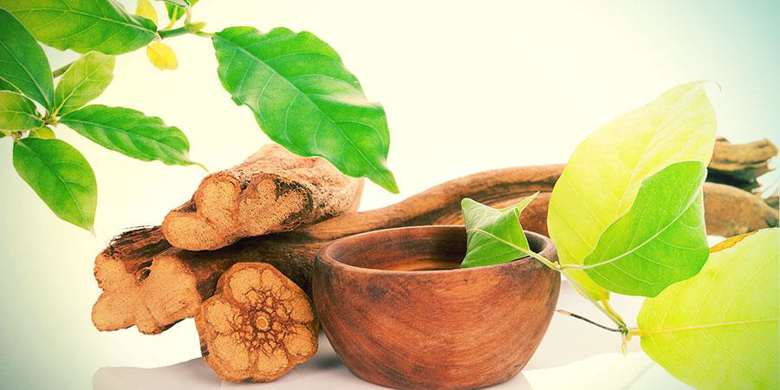
PRE-CEREMONY DIET
IMPORTANCE OF DIET BEFORE A CEREMONY
The diet is an essential element before an Ayahuasca ceremony
In Peru , the diet of the Shipibo Indians is very strict , but it allows a stronger connection with the plant.
In other countries of the Amazon, it may be less restrictive in terms of food, but all agree on the idea of absolutely proscribing alcohol, drugs, sexual activities ( including masturbation), drugs , pork, red meat, too much salt, too much sugar, spices , chocolate, all stimulants and all forms of violence .
Diet is not always easy for Westerners. It is nevertheless strongly advised to go on a diet at least 7 days , and if possible 10 days, before a ceremony . 15 days is even better. The closer you get to the ceremony , the more rigorously the diet must be respected .
Sometimes, not respecting a diet can block the absorption of the plant during the ceremony , even by increasing the dose several times. In other cases, a "purge" (vomiting) will take place to evacuate inappropriate foods from a non-respected diet , red meat for example, and the "work" will not be done. not as it should.
The more the regime is respected and rigorous, the more the “ work ” will be deep, powerful and effective!
After this work within this sacred process , it is important to eat healthy and avoid alcohol and other harmful substances, the day after the ceremonies and for two or three days , then to gradually resume your usual diet without excess . Those who are determined to preserve the benefits of their experience can extend the diet for 7 to 10 days. The benefits will only be more intense!
One aspect associated with the diet preceding an Ayahuasca ceremony is that of purity . Traditionally, shamans and apprentices refrain from consuming spicy and highly seasoned food , excess fat , salt , caffeine , acidic foods and avoid sexual activities before and after an ayahuasca session . Avoiding these foods is seen as a way to calm the mind and conserve energy for the journey. Going on a diet is also a way of showing respect to the Spirit of the Mother .
An Ayahuasca ceremony is always more effective and useful when the participant approaches it with clear intentions and an open heart and mind . Everyone's attitude will be the factor that will determine the degree of success and the benefits of the session. Privilege softness , tranquility , meditations .
It is possible to take Ayahuasca as part of a prolonged fast or a raw food diet, after consultation with an open minded doctor.

RECOMMENDED FOOD : (PREFER VEGETARIAN & ORGANIC)
• Vegetables : potatoes, green beans, zucchini, Swiss chard, beets, mushrooms, salad (except arugula), avocado (without abuse ), carrots, cucumber, eggplant, zucchini, peppers, asparagus.
• Fruits: apples, bananas, plums, pears, grapes, berries, pineapple; papaya, mangos.
• Apple juice and applesauce without sugar
• Dried fruits: almonds, nuts and hazelnuts
• Hard-boiled eggs : every 2-3 days
• Cereals : rice , quinoa, boulgour, corn
• Legumes : green lentils, coral lentils, kidney beans , split peas, chick peas
• All algae including Klamat spirulina tablets
• Drinks: natural & unsweetened fruit juices, rosemary, chamomile, ginger, verbena, cucurmina, mint (with moderation) and most infusions. Avoid caffeine and theine. Consume especially water, hydrate well before and especially the day of the ceremony.
✓ Dishes can be flavored with only raw olive oil (not cooked )
✓ Preferably use organic hygiene products: toothpaste, shower gel, shampoo, shaving foam , deodorant , etc.
✓ Listen to relaxing and inspiring music. Walking in nature. Sleep and rest well the previous days, especially the day before the ceremony.

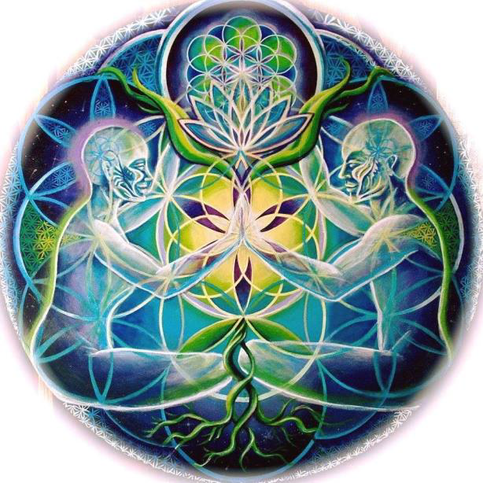

ABSOLUTELY AVOID!
• Alcohol, antidepressants, medications and any form of heavy drugs... Stop smoking marijuana
and industrial tobacco 5 days before the ceremony.
• Sexual activity and intercourse (including masturbation)
• Salt, sugar, chocolate, all spices including garlic, oignons and chile. teas, coffees
• Any protein of animal origin (includes fish, sea food, poultry)
• All dairy products: butter, cheese, yogurt, etc.
• Processed/industrial foods
• Fried foods
• Vitamins, food supplements and protein shakes
• Fermented, macerated or marinated products ( Miso , yeast, tofu, tamari, soy sauce, sauerkraut)
• Bread, pasta, all food that contains wheat flour
• Violence: films, music, violent remarks, violent emotions, aggressiveness, spending a lot of time
on screen, television , Facebook…Toxic people or situations.

OTHER PREPARATIONS and RECOMMENDATIONS:
It is recommended to use this audio as a support for your meditation during the 5 days preceding the ceremony, in a comfortable position, with headphones:
https://www.youtube.com/watch?v=g7EHidYj9BQ
These are isochronous sounds with Tibetan bowls and rain.
Isochronic sounds: thanks to them, we can bring the brain to know without effort different states or frequencies. It can have different benefits for the body and the mind. Thanks to this particular exercise, you will be able to familiarize yourself with the Theta waves, frequency: 4-7 Hz, and experience deep relaxation, similar to a meditative state, favoring imagination, visualization, lucid dreams, etc. Just watch and slow down your breath.
It doesn't matter if you fall asleep. You can listen to it several times a day. The intention is to prepare your brain, mind and body.
Another suggestion for a binaural session with theta waves, in the evening, replacing sleeping pills:
https://www.youtube.com/watch ? v=PpkSyuLEiPI
If you are already meditating, do your meditations every day before the ceremony.
If you do yoga, practice it every day before the ceremony (3 to 5 days)
In addition to self-care and diet, the mental, emotional and spiritual attitude towards the experience is important: openness, clear intention and certainty that we are doing something for the good of our being. Also, the security that we are with people who know what they are doing.
Attend the ceremony with the greatest respect!
Bathing or showering just before going to the ceremony would be ideal.
It is extremely important to know that the experience can cause vomiting, diarrhea, runny nose, crying, involuntary movements. This is all part of the purification/purging process that medicine performs in our body.
PEOPLE WHO CANNOT PARTICIPATE:
People with a history of epilepsy, with severe heart problems, having had a recent SERIOUS operation, people undergoing psychiatric treatment.
If you consider that you need a personal assessment before your participation, if you have any doubt or question that arises, contact us in trust. Don Ino: +52 33133 58095.
THE DAY OF THE CEREMONY:
There are two options for the start of the ceremony, 10 a.m. or 6 p.m. (which implies that the ceremony will last all night and that you will sleep at the ceremony location), we will decide together what is the right time for you or the group.
1. Bring something to keep you warm, your favorite pillow or blanket, comfortable clothes, sandals or the like to put on quickly to go to the bathroom, water to drink and bring something like organic food, dry or fresh fruits, all wheat cookies, etc.
2. On the day of the ceremony, it is very important to fast (not eat anything) and stay well hydrated. If the ceremony starts at 6 p.m., you are allowed to eat food very early in the morning but it must be light and easy to digest, then drink only water (8 hours of fasting at least).

3. The appropriate clothing for the session is as comfortable as possible.
4. Turn off cell phones during the ceremony.
5. The day after the session, it is recommended to rest, reflect and pay attention to your being.
6. Women who are menstruating will not normally be able to participate in therapy as this may make the process more difficult.
7. Do not bring any valuable jewelry please.
OUT OF RESPECT FOR THE CEREMONY, YOURSELF AND OTHERS, PLEASE BE PUNCTUAL.
There will be an introduction, a little meditation, and an individual harmonization. Duration: approximately 1 hour.
The ceremony will last approximately 6 to 7 hours. 8 hours in total on average.
After the ceremony you will return to your normal physical and mental state. You will probably feel over sensitive but you will be able to drive and do any normal activity.
It is recommended that you give yourself space to rest and reflect after the ceremony. At least 24 hours.
For your own safety, you must commit to stay until the end of the ceremony. Ayahuasca expands the consciousness and the senses and leaves the person much more sensitive physically and spiritually . Therefore it is not safe to go out on the street without being sure that you have come out of your induced trance .
YOU ARE ADVISED TO INFORM YOURSELF FULLY ABOUT TAKING AYAHUASCA FROM OBJECTIVE AND OPEN-MINDED SOURCES AND NOT FROM SOURCES WITH COMMERCIAL, POLITICAL, RELIGIOUS OR MORALISTIC AGENDAS.

MORE INFORMATION:
ICEERS (International Center for Ethnobotanical Education, Research and Service) In Spanish:
https://www.iceers.org/ayahuasca/
Anthropology of Ayahusca : VIDEOJosep M Fericgla :
https://www.youtube.com/watch?v=k-D_t229sDM 1
https://www.youtube.com/watch?v=9Al7FVkMhg02
Ayahuasca in TED talks - GRAHAM HANCOCK. War against consciences. Spanish. 18:44 minutes
https://www.youtube.com/watch?v=eLzgJnh-8pc
DMT the spiritual molecule: VIDEO 1.14.01 minutes
https://www.youtube.com/watch?v=fwZqVqbkyLM
Ayahuasca and psychotherapy Dr Claudio Naranjo . VIDEO 1.31:10 min
https://www.youtube.com/watch?v=Fo8pnhXVvYs

